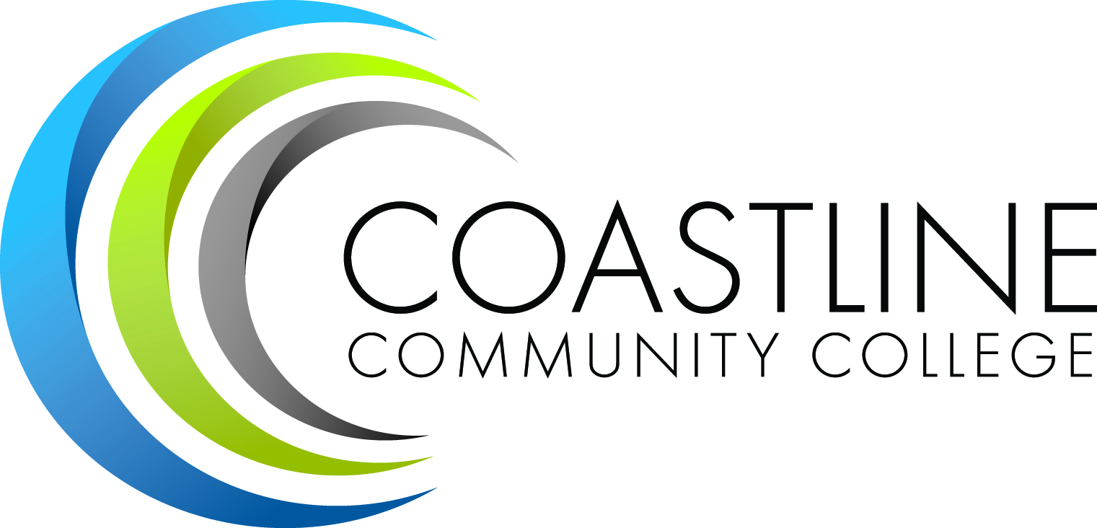
2010-2011 Planning Schedule
- October 21, 2010 – Kick Off Meeting

- December 1 - 3, 2010 – 3 days
  - Strategy Session #1 – Core Team & Steering Committee
  - College-wide Forum #1 – Wednesday, Dec 1, 2010 (TBD)
  - Interviews & Visitations – Learning Centers, ISD, Contract Education, Distance Learning & Department Chair Sessions
  - Strategy Sessions – External Stakeholders & Students

- February 4, 2011
  - Strategy Session #2 – All College Workshop at Le-Jao Center

- March 16 - 17, 2011 – 2 days
  - Strategy Session #3 – Core Team & Steering Committee
  - College-wide Forum #2 – Wednesday, March 16, 2010 (TBD)

- Week of April 11, 2011
  - Draft Education Master Plan report ready for review
  - Available for feedback from the Coastline College

- Week of May 2, 2011
  - Education Master Plan report finalized
**Days and times will also be available on the Educational Master Plan Website**
http://www.coastline.edu/masterplan

